Current Operable Unit 1 – SLKB Remedial Progress for Week Ending 3/26/10
Creamer Environmental Inc., National Grid’s Remediation Contractor, has completed excavation at the former Summers Lumber /King Bear property (SLKB) this week. Transportation of impacted soil and water off site as well as backfilling of the excavation which will continue till the end of the project. To date, 63 trucks have transported approximately 1647.9 tons or (1098.60 cubic yards) out of an estimated 1875 tons or (1250 cubic yards) of soil to Bay Shore Soil Management (formerly ESMI of NJ) for thermal desorption. Additionally 37,309 gallons of impacted excavation water have been disposed of at Clean Waters of Staten Island.
GEI, National Grid’s Remediation Oversight Consultant, continues to perform CAMP (Community Air Monitoring Program), which will continue throughout the project.

Two-Week Outlook
Creamer Environmental Inc., will continue to backfill the excavation area and will commence with the site restoration portion of the project. It is anticipated that transportation and disposal of impacted soils and water will cease the first week in April. Demobilization of temporary facilities and controls are also planned to be completed by the second week in April.
General hours of operation will continue to be Monday through Friday, 7:00 AM to 3:30 PM. However, work hours will be extended when necessary to maintain schedule or to complete critical tasks. Normal work activities are scheduled for Friday April 2nd (Good Friday).

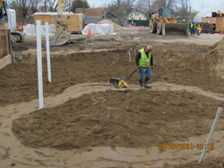
Compacting backfill material
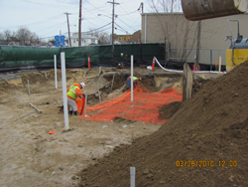
installing demarcation barrier for backfilling

